Title of the Paper (Times New Roman size 16, bold)
First author¹, Second author², Third author³ (Times New Roman 12 pt, bold)
¹First author affiliation, University/Institute (Times New Roman 11 pt); Email address (10 pt)
²Second author affiliation, University/Institute (Times New Roman 11 pt); Email address (10 pt)
³Third author affiliation, University/ Institute (Times New Roman 11 pt); Email address (10 pt)
* Corresponding author: Name

Abstract. The abstract appears before the keywords. Abstract must be about 300 words. However, it must be limited between 150 to 300 words. The abstract should clearly state, the objective, results and the conclusion of the work.
Keywords: Max 6 keywords in English, separated by comma, Italic Times New Roman 11 pt.

Introduction (TNR 14pt., bold)
The main text, (TNR 12pt., alignment in block, spacing 1,0) text, text, text, text, text, text, text, text, text, text, text, text, text, text, text, text, text, text, text, text, text, text, text, text, text, text, text, text, text, text, text, text, text, text, text, text, text, text, text, text, text, text, text, text, text, text, text, text, text, text, text, text, text.

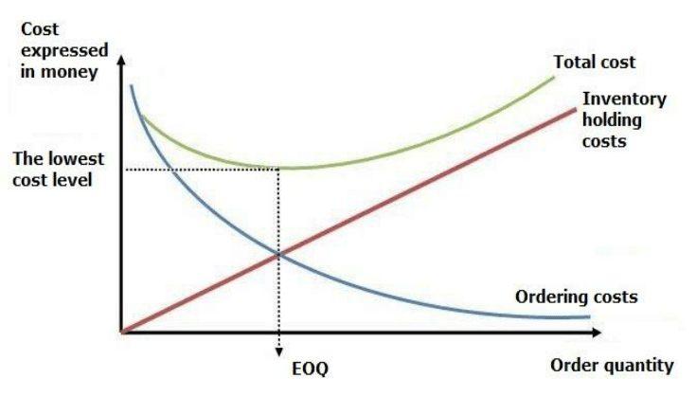
Figure 1: Figure description (TNR 10pt., centered, italics)

Source: (TNR 10pt. italics)
Text, text, text, text, text, text, text, text, text, text, text, text, text, text, text, text, text, text, text, text, text, text, text, text, text, text, text, text.

Title of the 2nd level (TNR 12pt., bold)
Text, text, text, text, text, text, text, text, text, text, text, text, text, text, text, text, text, text, text, text, text, text, text, text, text, text, text, text, text, text, text, text, text, text, text, text, text, text, text, text, text, text, text, text, text, text, text, text, text, text.

Title of the 3rd level (TNR 12pt., bold)
Text, text, text, text, text, text, text, text, text, text, text, text, text, text, text, text, text, text, text, text, text, text, text, text, text, text, text, text, text, text, text, text, text, text, text, text, text, text.
Tables and figures should be numbered and references to them must be in the text. Acceptable labeling for a table is Tab.1 and Fig. 1 for a figure.
Table 1: Table description (TNR 10pt., italics)
Times New Roman 10pt | Times New Roman 10pt | Times New Roman 10pt
Times New Roman 10pt | Times New Roman 10pt | Times New Roman 10pt
Times New Roman 10pt | Times New Roman 10pt | Times New Roman 10pt
Times New Roman 10pt | Times New Roman 10pt | Times New Roman 10pt

Source: (TNR 10pt., italics)

Equations
Equations (refer with: Eq. 1, Eq. 2,...) should be placed in the middle, denoted by numbers in round parentheses and transformed by equation conversion manager, do not use Print Screen or jpg format. For example:
(1)

Body of paper (TNR 14pt., bold)
The article must be divided into chapters. Introduction and conclusion are obligatory. It is recommended to adjust body of the paper to the common organization structure of scientific papers – IMRaD (Introduction, Methods, Results and Discussion).

Conclusion (TNR 14pt., bold)

Acknowledgment (TNR 12pt. bold)
This paper is an output of the science project…

References (TNR 14pt., bold)
References in text should be in this form (surname, year), for example:
One author: (Skinner, 2019)
Two authors: (Skinner & Parker, 2014)
More than two authors: (Parker et al., 2016)
For each work shown in the list of references must be a reference in the text. All citations in the text and all references must meet APA styles.
(Book style - Author’s surname, Initial(s). (Year). Title (in italics). Location of Publisher: Publisher.)
(Journal - Author’s surname, Initial(s). (Year). Paper title. Journal name (in italics). Volume and issue numbers. Inclusive pages.)
(Conference paper or contributed volume - Author, (Year). Paper title. Proceedings title (in italics). Location of Publisher: Publisher. Retrieved from URL)

Footnote TNR 10pt.

